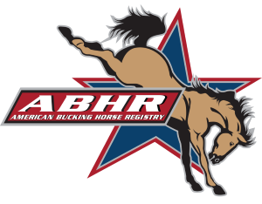

**American Bucking Bull, Inc.**

101 W. Riverwalk, Pueblo, CO 81003

**Phone:** 719-242-2747 **Fax:** 719-242-2746

[**www.americanbuckingbull.com**](http://www.americanbuckingbull.com)

**2021 ABHR BREEDER APPLICATION**

**NEW BREEDER RENEWAL**

**NAME: ABHR Breeder# (for renewals): ____**

**RANCH NAME: ________________**

**MAILING ADDRESS: ________________**

**CITY: ____________STATE/PROVINCE: COUNTRY________**

**ZIP/POSTAL CODE: E MAIL: _ ________________**

**PHONE #: ( ) CELL #: ( ) __**

|  |  |  |  |
| --- | --- | --- | --- |
| **Junior Breeder: (18 & Under as of 1-1-2021)**  ***Birth Date Required*** | **Date of Birth ___/___/____**  **REQUIRED for Junior Membership** |  | **$30.00** |
| **Standard Breeder:** |  |  | **$75.00** |

**Make checks payable to American Bucking Bull, Inc. (ABBI) US DOLLARS ONLY**

**\*A 2% handling fee is added to all credit/debit card transactions.**

**\*Includes a subscription to Bucking Stock Magazine\***

**\*You must be a breeder in good standing with ABBI in order to register horses**

**\*The American Bucking Bull Inc. reserves the right to use any information contained within the ABBI Registry and/or ABHR Registry.\***

* **Authorized signature for the credit card listed below : _____________________________________________**
* **Name on Credit Card : ____________________________________ Type (VISA/MC/AMEXP/Discover)**
* **Billing Address: ___________________________ City___________ State/Province _______ Country____**
* **Credit Card Number : __________ __________ _________ __________**
* **Exp. Date: ___________CSV ___________ (back of card) Billing ZIP/POSTAL: __________________**